**Task: Setup the CloudWatch alarm for 80% CPU Utilization.**

Step:1 Prepare the EC2 server for the CloudWatch alarm and make sure it will in a running state.

Step2: Create an Alarm from CloudWatch service All Alarm section.

Step 3: Copy instance id select the cpu utilization metrics from the EC2 Pre-Instance Metrics.

Step 4: Set the metrics name and it’s condition 80%

Step 5: Setup the Notification configuration action, for that firstly will setup the SNS configuration.

Provide the Email endpoint to getting the updates and click on a **Create topic.**

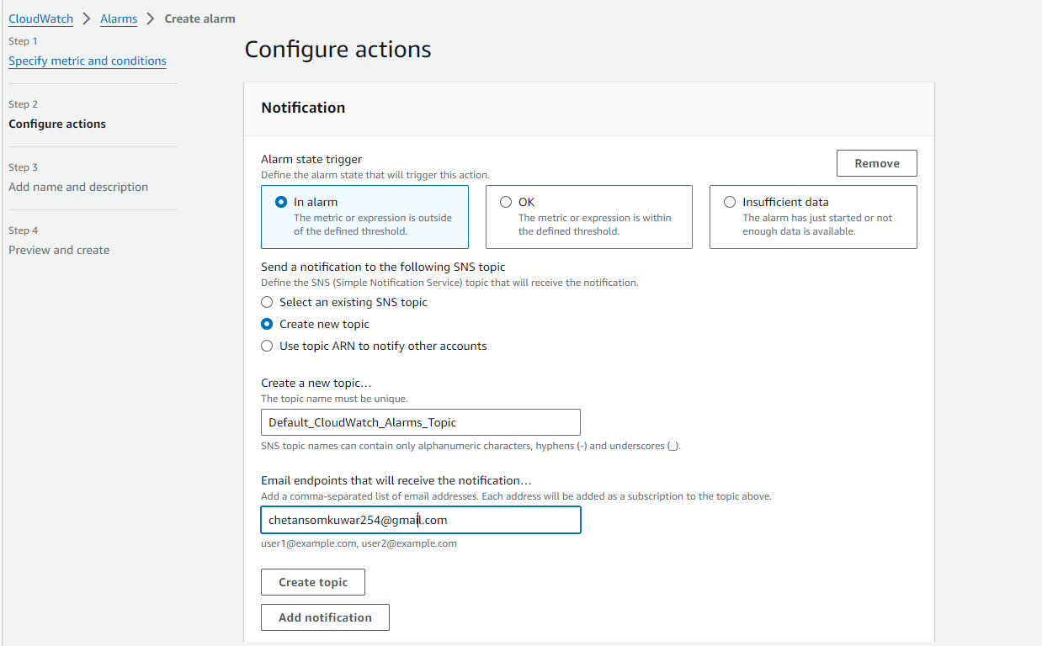

Step 6: Open the AWS SNS Console from the given link either from SNS service and do the conformation from given email address, check the email and confirm the subscription.

SNS Topic’s subscription is in pending state.

Step 7: Confirm the subscription from email just needs to click on **Confirm Subscription**.

Now you can see our subscription is confirmed successfully...

Step 8: Now attach created the SNS topic to Alarm.

Step 9: Set the Alarm name & preview and create the alarm.

Step 10: Now, Alarm is configured, successfully.

